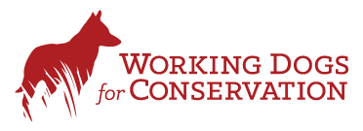

Rodent Dog Internal Biosecurity
Report
2020-21
Funded by the FIG Environmental Studies Budget
30th September 2021

Naomi Cordeiro Biosecurity Dog Handler Green Hound Limited

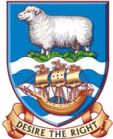

Contents
Acknowledgements 3
- Introduction 3
- The Plan and Methodology 4
- Results 5
  - Inter-Island Cargo Checks 5
  - Concordia Bay and New Haven Searches 5
  - Kidney, Cochon, Top and Bottom 5
  - Bleaker 7
  - Yacht/Launch Searches 10
- Trial 11
  - Cape Pembroke 12
  - Port Harriet 15
- Outreach 18
6. What went well 18
References 19

Acknowledgements
Many thanks to the Falkland Islands Government, particularly the Environment Department,
Workboat Services, Megan Vick, Working Dogs for Conservation, Sulivans, Shallow Marine Survey Group, the Rendell family, Paula Muñoz, Sally Poncet, Ken Passfield, Tom Busbridge, Ross James, Ollie James, and Roddy Cordeiro.

Introduction

A three-year Environmental Studies Budget (ESB) grant was awarded in September 2020 to enhance the protection measures in place to prevent re-introducing rodents to islands around the Falklands that are free of rats and mice. The project also covered a number of surveys on previously eradicated or known rodent-free islands to confirm their status. In doing so the project hopes to raise awareness of the impact rodents have on habitats and species and show the benefits of good biosecurity.

Specifically, the project will:
  - Check cargoes bound for rodent-free islands travelling on the Concordia Bay
  - Check the ferry itself at regular intervals
  - Check for rodents and advise on control at New Haven
  - Confirm rodent free status of some privately and government owned islands
  - Run trials to determine the efficacy of the dog versus ‘human’ monitoring for rodents at low densities
  - Hold a range of outreach sessions to share the work of the project This report summarises the first year of the project.

The Plan and Methodology
The plan was to conduct inter-island cargo checks throughout the year and carry out the island
survey work in winter. This was done both to ensure the surveys could be fitted around other commitments but also to ensure surveys were scheduled when the lowest abundance of wildlife would be present. This both reduces distractions for the dog and protects the wildlife.

During island surveys the dog was on lead and within sight of the handler at all times.

It was considered impossible for the dog team to cover every inch of every island in the time allotted, so high risk areas were determined and targeted. The coastline nearest to the next rodent-infested area was considered the most important area to check as it is not only the first avenue for rodents to enter an island but also a habitat for feeding. Empty bird burrows and any old rodent burrows, where present, were also considered an important area of focus as it had been noted on Bleaker (during a previous visit by the rodent dogs) that rodents were using empty penguin burrows for nesting. Buildings, where present, were also targeted and, where time allowed, other random areas were also checked.

Another key area for rats is any place with access to fresh water as they are more reliant on fresh water than mice for survival. Rodents often build their burrows around springs so these areas were always checked.

This year, Covid-19 meant that there was more flexibility in the dog team’s schedule to allow island searches to take place throughout the year, where possible.

IMAGE CANNOT BE DISPLAYED

Figure 1. View from Cochon Island

Results
The results of the searches carried out throughout the year are presented below.

  - Inter-Island Cargo Checks
In total, 68 containers were searched on 13 voyages to outer islands.

In some cargoes residual odour (rodent urine) was identified by the dog, particularly on bags of animal feed and stores. This can be distinguished by the handler from live rodents through training and reading the dog’s behaviour. Otherwise, no ‘live’ indications were given by the dog.

  - Concordia Bay and New Haven Searches
The Concordia Bay was searched three times throughout the year. During each dog search,
different areas of the vessel were searched with the galley and passenger lounge always searched as they are considered higher risk being close to food, water and access to the deck. No live rodents were found during any searches.

New Haven searches confirmed there are rodents in that area and traps are in place to manage this.

  - Kidney, Cochon, Top and Bottom
Kidney Island was search on 22nd March, this was done earlier than previous years as we wanted
to hit a ‘sweet spot’ between a higher number of rodents (if present) towards the end of summer and a lower number of wildlife after birds had fledged but before any rodents would start to die off. This was also possible this year as Covid-19 meant there were no cruise ship searches, which would normally be ongoing at this time of year.

Top Island was searched on 11th April and Cochon and Bottom Island were attempted on 6th June but landing was not possible, and were finally searched on 17th June. The search on Top island was cut short a little due to the high number of fur seals and sea lions blocking the path.

A GPS track of the search area was taken with a new tracking device bought for the project and is shown below.

As before, coastal areas alongside the mainland were prioritised during the search as these were considered to be higher risk areas, i.e. potential arrival sites for rodents to the islands (shorelines) and potential areas of harbourage (any buildings, bird burrows etc).

During the surveys, a leader walked the track ahead of the dog team to ensure a safe path for the team and avoid any wildlife. The dog’s behaviour was interpreted by the handler throughout the trek, with any indications and behaviour changes noted. No indications that there was any rodent scent on the track were found.

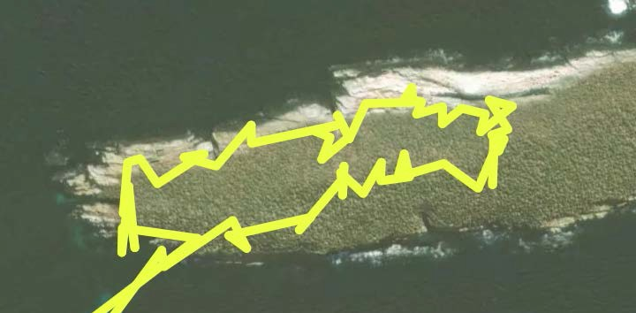
Figure 2. Search track on Top Island

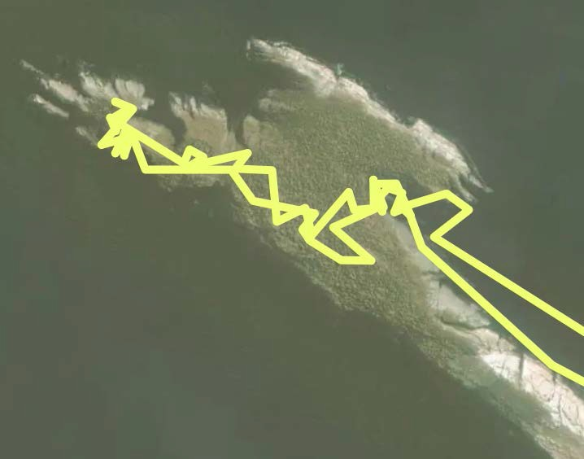
Figure 3. Search track on Cochon Island

Bleaker
With kind permission of the Rendell family, Bleaker Island was search between 18th and 21st May
2021. A GPS track was taken throughout, see below.

The areas closest to the mainland (or nearest rodent infested area) were prioritised during the search as these were considered to be higher risk areas, i.e. potential arrival sites for rodents to the islands (shorelines) as well as potential areas of harbourage (any buildings, bird burrows etc). Previous areas of high density rodents were also searched to ensure the eradication had been successful and all areas surrounding fresh water were searched. The dog indicated on two penguin/rodent burrows, which were thoroughly investigated by the team and no further signs of rodent presence were found (faeces, tracks, caches of food etc.). The dog was not intensely interested in the burrows (as he would be for the presence of live rodents) and in one instance gave a final indication on a sod of peat. It was therefore concluded that the years of presence of rodents has tainted the soil in some areas giving a larger scent picture for the dog and causing the interest. Two years post-eradication it is also possible that there may still be remains of dead rodents in some burrows.

All buildings in the settlement, as well as the jetty area, were searched and the dog indicated in the shearing shed – this was attributed to residual odour, as the shearing shed was made of wood, which ‘soaks up’ and holds odour for many years, as we have found on vessels. The dog’s reaction to live rodents versus residual odour is clear so we can be confident that the indication by the dog did not represent a live rodent presence.

The dog’s behaviour was interpreted by the handler throughout the trek, with any indications and behaviour changes noted. Three points of interest were noted (two penguin burrows and the shearing shed), see Figures 4-7 below, and these were attributed to residual odour from previous areas of dense rodent infestation that still presents a significant odour picture for the dog. As there was not time to cover the entire island with the dog, ‘spot checks’ were conducted at all areas where fresh water is normally present and at various areas around the island.

Where rodent monitoring stations were found these were checked and no rodent sign was found, nor did the dog indicate.

It should be noted that the dog’s GPS tracker (the yellow track) ran out of battery towards the south end on Day 2. Cassard Point was searched but the track was not recorded. The team noticed it had run out of battery and were able to track the search with another GPS tracker on the way north, so the picture looks a little different in Figure 6.

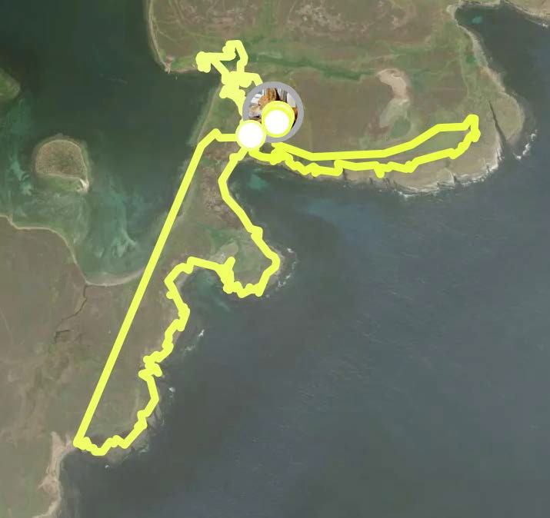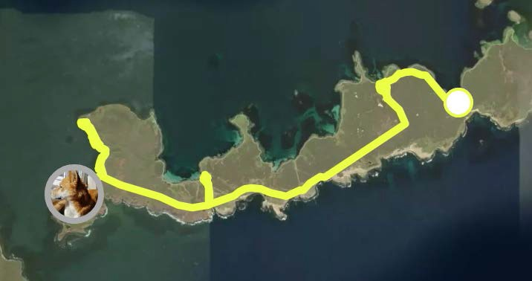Figure 4. Search track on Bleaker Island, day 1. Indication on residual odour noted in the shearing shed (blue star)

Figure 5. Search track on Bleaker Island, south bound, day 2. Indication on residual odour noted in one penguin burrow along the western end where previously high numbers of rodents had been noted

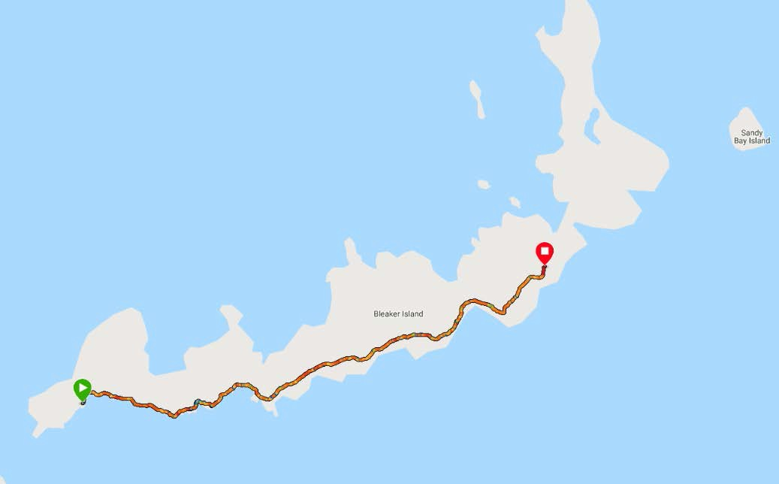Figure 6. Search track on Bleaker Island, north bound, day 2. Indication on residual odour noted in one penguin burrow along the southern coast where previously high numbers of rodents had been noted
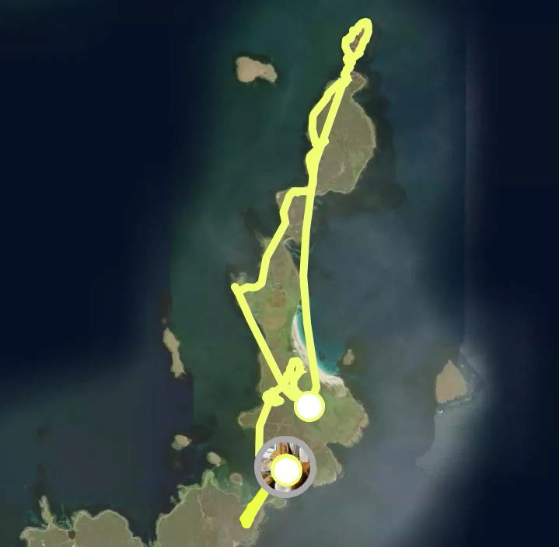
Figure 7. Search track on Bleaker Island, day 3, no indications

Although the dog indicated in three areas on Bleaker Island, these were not thought to be live rodents but residual odour attributed to the previous infestation, giving confidence that rodents have not reinvaded Bleaker Island and the eradication has been successful.

A further check will be made on Bleaker next winter (~May 2022) to complete the best practice three-year wait post-eradication.

Yacht/Launch Searches
Following an advert on the radio, one local yacht took up the offer to be searched before a visit
to Kidney Island. Many other local yachts were visited throughout the year by the dog either for training or to access islands. Additionally, almost all FIC and Sulivans launches have also been visited by the dog throughout the year.

Trial

A number of options were discussed with stakeholders as to what would be the most useful aspect of the dog programme to test with a trial. Determining how much better the dog is at recognising or alerting to rodent presence than humans was not felt a productive use of the team’s time as this has already been proven in a number of different studies by teams throughout the world. (Johnston 1999; Dahlgren et al. 2012, Richards et al. 2021).

In part inspired by the events on Lord Howe Island, it was felt useful to determine how the dog team perform at identifying rodent presence at low densities. On Lord Howe, an eradication took place and rodent monitoring stations placed throughout the island. Dog teams were also employed, much like they have been here in the South Atlantic, to check cargoes and vessels bound for the island. The dog teams were not routinely used to search in the towns and settlements as it was felt there was sufficient monitoring being done by humans using monitoring stations with chew sticks etc. In 2021 a rodent was spotted within a settlement on Lord Howe, despite no indications being given at the rodent monitoring stations. Dog teams have subsequently been employed on Lord Howe to determine the presence of rodents in all areas of the island and the final eradication of the last rodents continues (as at September 2021).

The dog team here have been successful in determining rodent presence on both vessels and islands and it would be beneficial to understand how human monitoring differs from monitoring effort by the dog team. This will not only support the use of the dog team in determining the success or otherwise of rodent eradications in the Falklands but could also help to show their value as part of an incursion response (both in the Falklands and South Georgia), where low densities of rodents may be present but are not yet showing their presence on chew sticks etc.

Rodent monitoring boxes, such as the one pictured in Figure 9, were deployed in winter at Cape Pembroke (CP) and Port Harriet (PH). It is assumed that there are mice on CP (as noted during the Watch Group’s project in 2020) but it is unclear whether there is a sizeable rat population. Anecdotally it has been said that the cats on CP keep the rat population in check, combined with the lack of tussac cover, which may mean there are very low densities. Monitoring stations were focussed on the northern coastline as this poses a threat to the tussac islands just to the north, see Figure 10. At Port Harriet, it is suspected but not confirmed that rats are present to benefit from the abattoir dump site.

Rodent monitoring stations did not include any poison as toxic bait has been shown to put off rodents from investigating even if only the smallest amounts of poison are included. Also, the aim of this project is not to curb population but solely a monitoring exercise.

The monitoring was checked every two weeks for 6 weeks and the dog was used to search the area only once. It is planned to repeat the survey (both human monitoring and dog searches) each quarter to see if there are any differences.

Cape Pembroke
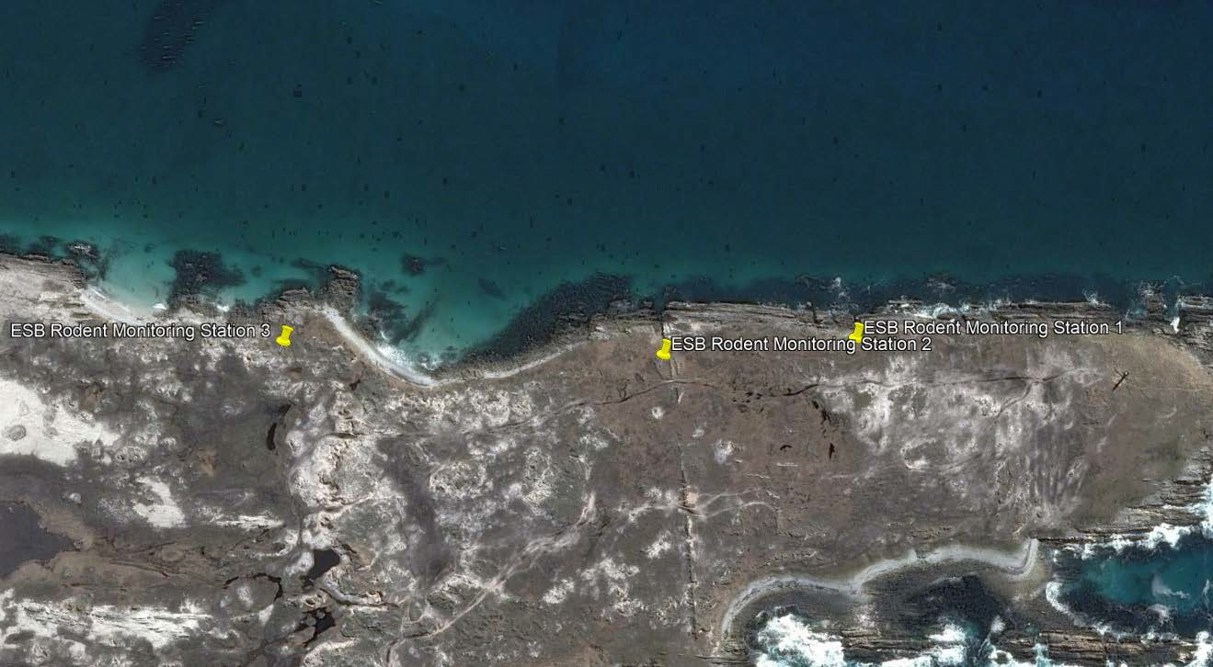
Figure 8. Rodent monitoring stations on the north coast of Cape Pembroke

Wax tags and chew sticks were deployed in tunnels and marked up in case they were disturbed by walkers, see Figures below.

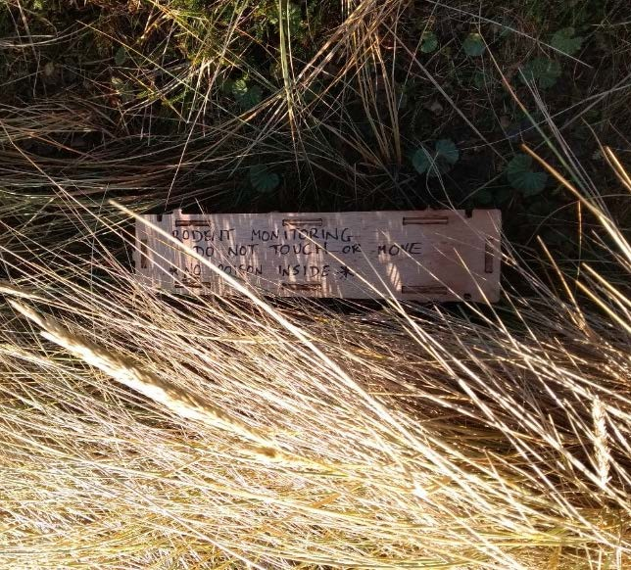

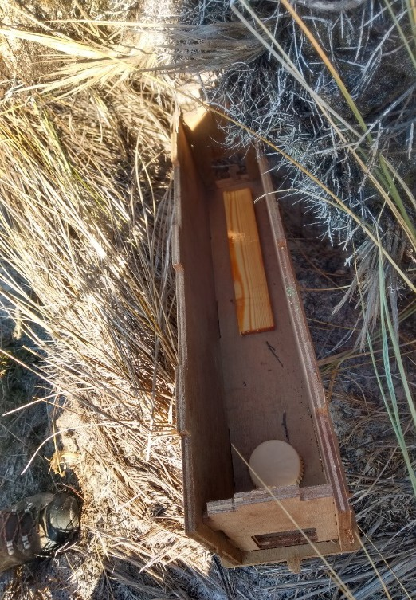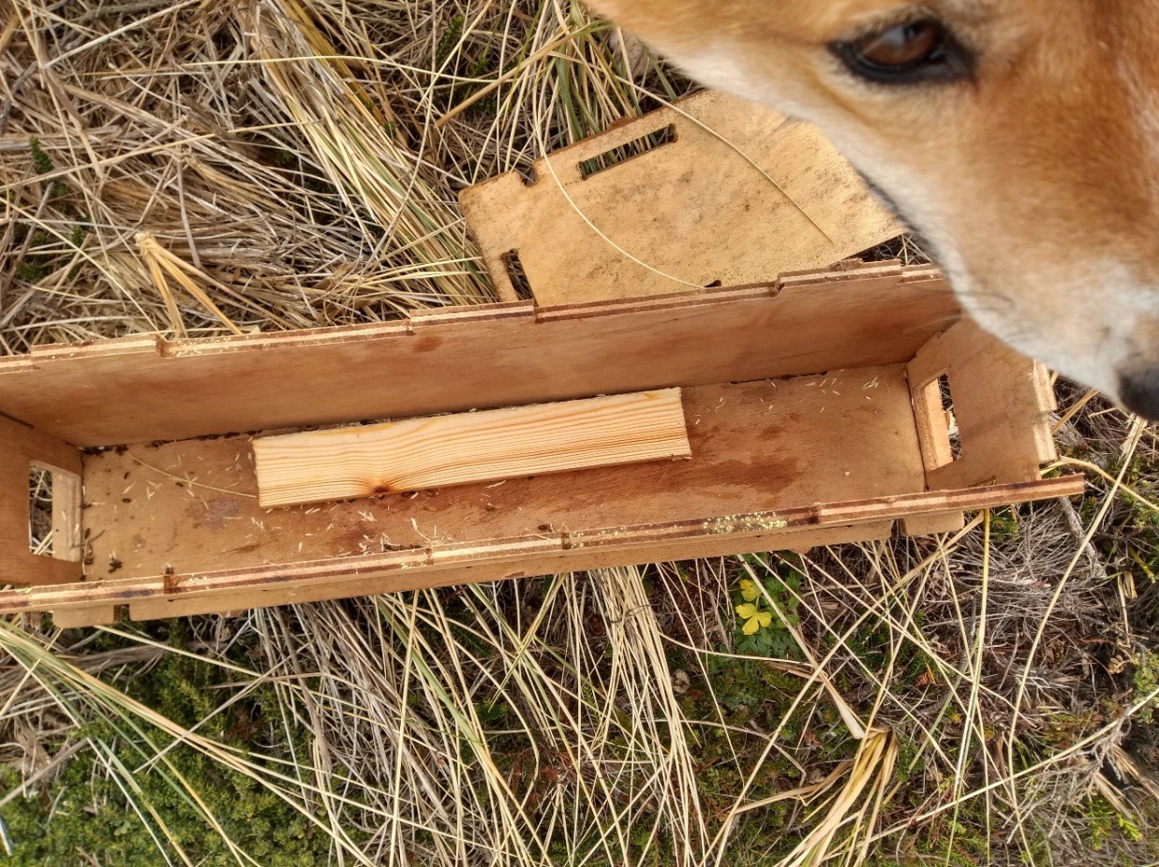Figure 9. Top left: Inside each rodent monitoring station when set: a chew stick and wax tag. Top right: Rodent monitoring station in situ on Cape Pembroke. Bottom: Mouse faeces in the monitoring box, wax tag has gone but chew stick remains untouched.

Two weeks after setting out the boxes the wax tags had been eaten by mice (identifiable by faeces size and shape) but the chew sticks remained intact. It was decided not to replace the wax tags but to leave the chew sticks in place to see if any rat activity could be found – rats typically take two weeks to acclimatise to any new things in their environment and won’t investigate before then.

Four weeks after the tunnels were deployed they were checked again and this time the central station’s (station 2) chew stick had been gnawed and there were larger faeces inside the tunnel, indicating rat presence.

The dog search took place at the same time (4 weeks after tunnels were laid) and the dog’s indications and finds are shown below. The dog also indicated on each monitoring tunnel but this is not recorded as a separate find by the dog.

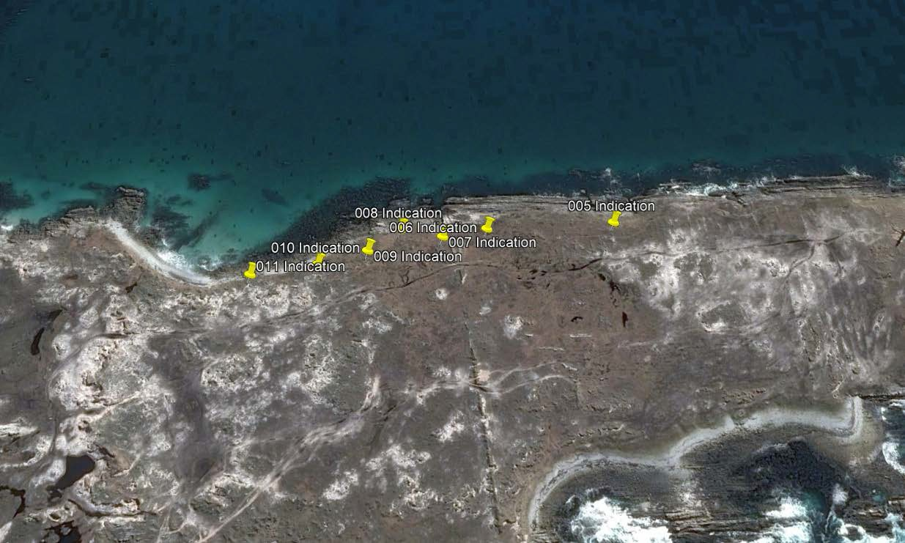

Figure 10. Dog’s indications during winter survey at Cape Pembroke, see also notes below.

Indication No. | Notes/findings
005 | Indication – mouse? nest
006 | Indication – mouse? latrine
007 | Indication – mouse nest?
008 | Indication – (tail wag) nest/live smells mousey to handler
009 | Indication – mouse hole
010 | Indication – mouse hole
011 | Indication – mouse/rat hole

Port Harriet

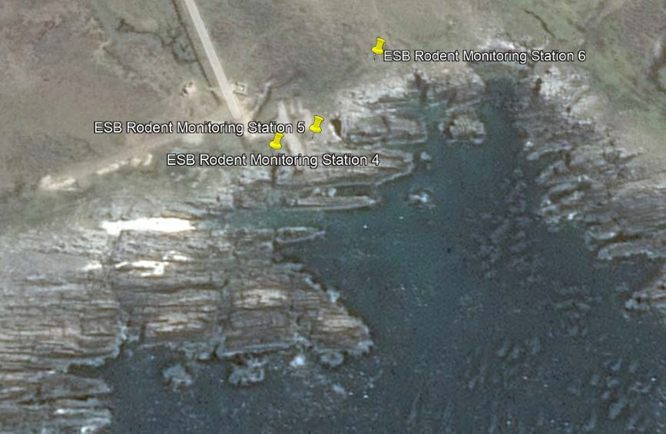At Port Harriet (PH) there are thought to be rats but it is unknown whether there are mice present as well. Whilst setting out the monitoring boxes, feral cats were seen, which may have an impact on rodent abundance.

Figure 11. Rodent monitoring stations at Port Harriet

Due to a GPS error the dog search could not be conducted 2 weeks after the initial placement of tunnels. However, a visual check indicated none of the monitoring bait had been touched at any station, this was also true after 4 weeks – neither the wax tag nor chew stick had been nibbled and the dog confirmed that the tunnels had not been investigated by rodents. The dog was present while visual checks were completed 2 weeks after tunnels were laid and showed interest in an area to the south east of monitoring station 6. As such, this station was moved slightly, see red arrow above.

A search with the dog was conducted 4 weeks after the monitoring boxes were in place, the dog showed hunting behaviour indicating the presence of live rodents nearby in the two areas below with blue boxes and indications are shown below with yellow pins.

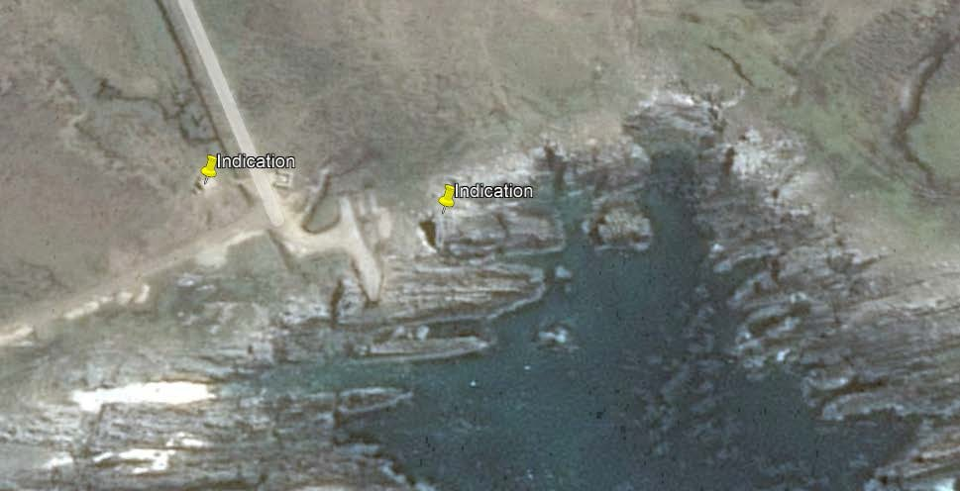Figure 12. Dog indications and behaviour changes at Port Harriet

From the initial searches and monitoring the following pros and cons of each method have been compiled:

 | Dog search |  | ‘Human’ monitoring
 | Pros | Cons | Pros | Cons
Time | Faster, more  immediate results (searches took  ~1-3 hours) | A comprehensive  search of the whole area would take longer (0.5-1 day) |  | Can take over  two weeks to determine presence (for rats and longer where food is abundant)
Location | Identifies where  rodents are present |  |  | If boxes not in  the right spot, or an  abundance of  other food available, rodent presence may be missed
Types of  area |  | Searching in areas  with animal carcasses and bones is  distracting | Can be done at  any location
Species | Only identifies  rodents | Cannot  distinguish | Possible to  distinguish | Other species  can mark the

 | Dog search |  | ‘Human’ monitoring
 | Pros | Cons | Pros | Cons
 |  | between rats and mice | between chew marks of rats and mice | wax tags and chew sticks which may be mistaken for rodents

The dog is able to identify areas where rodents are present within the search area as opposed to boxes which are static and if not placed in the right spot, will not pick up presence, as demonstrated at PH. At PH, searching in an area with lots of animal carcasses and bones was quite a challenge for the dog as these were distracting, however after some time he was able to work through it. At PH it was unclear whether the low abundance of rodents meant the tunnels were not investigated or that the sheer abundance of other food gave rodents no reason to investigate the tunnels. The dog search confirmed that rodent abundance is low at PH at this time of year.

The monitoring boxes give a slightly clearer indication as to whether it is rats or mice that are present but do need to be regularly checked and re-freshed, and it can take time for rodents to explore and use the tags or chew sticks, this is particularly true when there is an abundance of other food available, as at PH. The trial will continue into the next year to gather a full year of data and monitor any differences over the seasons.

Outreach
Articles were published in the Penguin News and Wool Press, and two interviews given with
Falkland Islands Radio; the first to offer free yacht checks and the second to discuss the rodent monitoring. Facebook and Twitter were used regularly to share the dog team’s work.

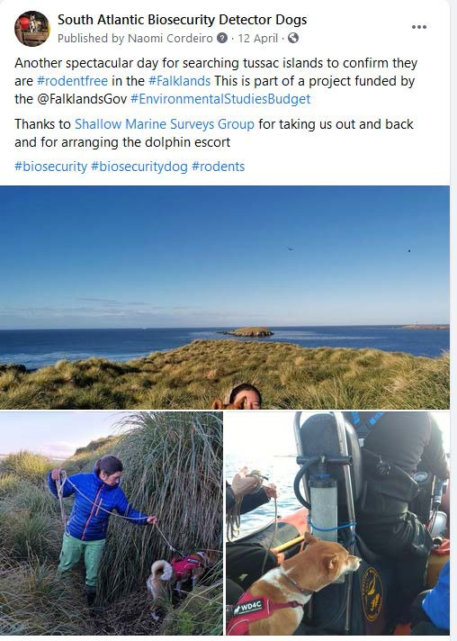
Figure 13. Facebook post about island searches

What went well
  - A quiet cruise ship year, due to Covid-19, meant that we were able to visit tussac islands during the ‘sweet spot’, this may not be possible in coming years due to clashes with other seasonal work for the dog team;
  - Due to a smaller number of vessels over the summer there were fewer clashes between the vessel searches for GSGSSI and cargos on the Concordia Bay;
  - Despite Covid-19 the team were able to re-certify in the islands with the help of the RAF Police Dog Unit, who provided independent oversight of the test;
  - Stanley businesses and establishments have been very helpful in allowing us to train at their locations around town;
  - Social media response has been positive.

References
Dahlgren DK, Elmore RD, Smith DA, Hurt A, Arnett EB, Connelly JW (2012) Use of dogs in wildlife
research and management. In: Silvy NJ (ed) Wildlife techniques manual: research, vol I. John Hopkins University Press, Baltimore, MA, pp 140–153.

GSGSSI (Government of South Georgia & South Sandwich Islands) & WD4C (Working Dogs for Conservation). 2021. Biosecurity Detector Dog Team South Atlantic Standard Operating Procedures Version 1.2. Internal document.

Johnston JM (1999) Canine detection capabilities: operational implications of recent R & D findings. Institute for Biological Detection Systems. Auburn University, Auburn.

Richards NL, Hartman J, Parker M, Wendt L, and Salisbury C (2021) The Role of Conservation Dog Detection and Ecological Monitoring in Supporting Environmental Forensics and Enforcement Initiatives. In S. C. Underkoffler, H. R. Adams (eds.), Wildlife Biodiversity Conservation. Springer, Cham. https://doi.org/10.1007/978-3-030-64682-0_11

