Standard Operating Procedures (SOPs) for the management of environmental data collected by the hydrocarbons industry in the Falkland Islands

1.Background
In 2012 SAERI secured external funding for a project to develop a regional information management system and GIS data centre (IMS-GIS data centre). The regional component of the project has, to date, involved project staff developing standard data management systems in the Falkland Islands, Ascension Island and St. Helena, with work beginning in Tristan da Cunha, and setting a method for a continuous harvesting of metadata for all the datasets generated in the territories.
A standard metadata form has been adopted and fed into a regional metadata catalogue which is published online through the IMS-GIS data centre webpage hosted on the SAERI website (http://south-atlantic-research.org/metadata-catalogue). The Falkland Islands core component of IMS-GIS data centre has been to focus on creating a central data repository for environmental data collected either by researchers or by third parties such as the hydrocarbons industry.
The central environmental data repository is therefore an integral part of the Gap project. The management and analysis of data required for and generated by the hydrocarbons industry was recognised as being vital for supporting Environmental Impact studies and for delivering an evidence-based approach to effective environmental management of the industry.
In the last 4 years there has been considerable advance in how environmental data are managed in the Falkland Island through the establishment of the IMS-GIS data centre. As stated above, this provides a system to catalogue and store environmental data, with their associated metadata, and facilitates its availability to researchers, mangers and commercial entities. Research licences already require that a copy of data is left in the Falkland Islands at the IMS-GIS data centre which will become their custodian and curator.
A similar data licence applicable to environmental data generated by the hydrocarbons industry has been developed and this document aims at describing/detailing clear Standard Operating Procedures (SOPs) from the point of proposing an environmental study up to data/metadata submission and cataloguing in the IMS-GIS data centre.
The overall responsibility of the correct functioning of the SOPs is shared between relevant government departments (Department of Mineral Resources and Environmental Planning Department), the IMS-GIS data centre and the hydrocarbons industry.
The SOPs involve four key points:
- Data identification and listing;
- Data documentation and traceability;
- Data delivery;
- Data archiving.

2.Definitions

Operator: The oil and gas company which has obtained a licence from the Falkland Islands Government to undertake exploratory or development works in relation to the extraction of hydrocarbons from the marine environment.
Contractor: Individual or organisation contracted by the operator to carry out either the environmental baseline survey or the environmental monitoring survey.
Data custodian: Information Management System and GIS centre (IMS-GIS data centre) at the South Atlantic Environmental Research Institute (SAERI)
Data requestor: The individual or organisation requesting the data from the IMS-GIS data centre
Data owner: The legal owner(s) of the data. Noting that any dataset submitted may have more than one data-owner.
Data manager: The person occupying the post as data manager at the IMS-GIS data centre in SAERI.
Data: The individual items or records (both digital and analogue) usually obtained by measurement, observation or modelling of the natural world and the impact of humans upon it. The definition includes data generated by an environmental baseline survey in support of Environmental Impact Assessment, which can be obtained through quantitative approach, e.g. complex systems, such as information retrieval algorithms, data assimilation techniques, the application of models and/or through a qualitative approach e.g. processed results of interviews and questionnaires (not the actual answers from interviewees).
Confidential data: The data cannot be disclosed because by making the data public an individual or organisation or environmental feature can be directly at risk or put in a condition to be at risk.
Commercial data: The data that have commercial value or have been designated commercially sensitive. These data are NOT STORED at the IMS-GIS data centre
FIG: The person in the Department of Mineral Resources (DMR) or Environmental and Planning Department (EPD) responsible for the liaison with the Operator as far as the data is concerned.
ES form: Environmental Survey form which describes in detail the purpose and method of the environmental survey.
ES permit: Environmental Survey permit which enable the Operator to carry out the environmental survey.
DID: Data Intention Document which defines data to be collected, roles and responsibilities of organisation(s) participating to the survey, timeframe, quality assurance methods to be adopted within the survey.

3.SOPs overall workflow
Roles:
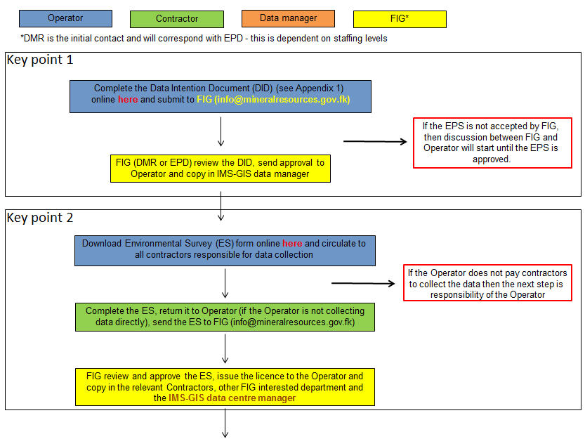
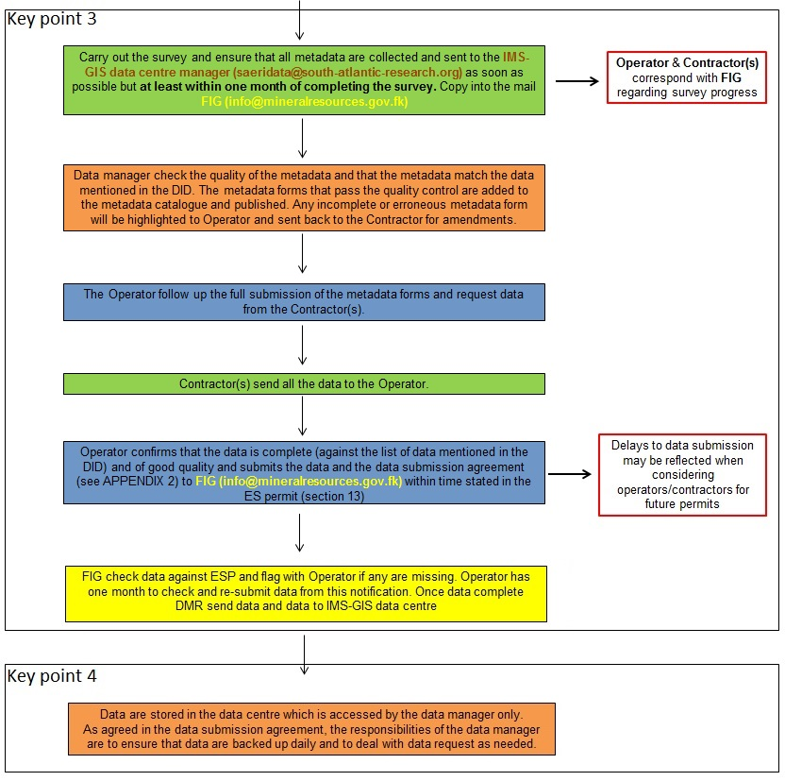

2.Requesting data from the data centre
Once the metadata records are in the online catalogue they can be searched and retrieved by anyone (http://www.south-atlantic-research.org/metadata-catalogue ). Below the workflow describing the way the data manager deals with a request for environmental data owned by the hydrocarbon industry.
2.1 Workflow
Roles:

