FALKLAND ISLANDS GOVERNMENT

Fisheries Department



GUIDANCE NOTES FOR MASTERS
(TRAWLERS)
2023

Guidance notes for Masters of Licensed Fishing Vessels

These guidance notes are to assist Masters of licensed fishing vessels within the FICZ/FOCZ. They do not replace current Falkland Islands Fisheries Regulations and should be read in conjunction with those regulations and orders. Further information can be obtained from:

Fisheries Department
P O Box 598
FIPASS
Stanley
Falkland Islands

Telephone: +500 27260
Fax: +500 27265

licensingofficer@naturalresources.gov.fk

Relevant legislation includes:

The Fisheries (Conservation and Management) Ordinance 2005

The Fishing (Nets and Supplementary Net Equipment) Regulations Order 1990
The Fishing Regulations Order 1987

This is not a complete and exhaustive list. Masters should be aware of all relevant legislation.
1. GENERAL INFORMATION

1.1 To whom do the regulations apply?

The Fishing Regulations apply to ALL fishing vessels licensed to fish within the Conservation Zones and to any fishing vessel on passage through the FICZ/FOCZ. This includes any operations connected to fishing (e.g. transhipping, processing, storage or carriage of fish etc.).

1.2 Fishing licences

- The licence contains a number of conditions you must abide by.

- You must carry your licence on board the vessel at all times and produce it for inspection when requested to do so by a Fisheries Officer, or other authorized officer.

- A licence is valid only for the period, species and area stated upon it.

- The territorial seas of the Falkland Islands are 12 nautical miles, including Beauchene Island. Licences are currently endorsed for you to fish in any part of the territorial sea included within the valid area for your licence plus up to 3 nautical miles from the baselines from which the territorial seas is measured.

1.3 Inspection prior to or on completion of fishing

Trawlers arriving for licence collection and briefing will require a net inspection if a finfish licence has been allocated. In order to avoid unnecessary delays, any additional nets that will be used during the season must be ready for inspection by the Fisheries Officer. See also 1.4 below.

All vessels which are leaving the Falkland Islands zones shall give Stanley Port Control 72 hours’ notice and may be required to bring their vessel to Stanley for inspection prior to departure from the fishing waters.

This also applies to any vessels intending to send FISHEND reports prior to returning to their homeport following completion of their fishing period.

1.4 Pilot Ladders

It is important that vessels have properly constructed and secured Pilot ladders to facilitate boarding by the inspecting Officer. Pilot Ladders are to be constructed and fitted according to the provisions of SOLAS Chapter V, Regulation 23 (Consolidated Edition 2020)

1.5 Display of callsign and name

The vessel must at all times when within the fishing waters:

a) Fly the flag of its country of registry

b) Have its name and port of registry painted in a permanent colour contrasting with the colour of the background on which they are painted on the stern of the vessel. The name has to be painted in similar lettering on the port and starboard bow, in letters not less than 10cms in height and 2cms in breadth.

c) Keep its radio call sign displayed at all times on each side of the vessel’s superstructure and is to be kept clear of obstruction. It is to be painted in white on a black background or the reverse. Letters and numbers are to be each at least 1 metre by 25cm wide.

1.6 Use of English language

All records, reports and communications are to be in English; therefore at least one member of the fishing vessel’s crew should be reasonably fluent in English. If you are operating as part of a ‘fleet’ the English speaker can be on board another vessel, providing he is available at all times.

1.7 Stowage of gear

Any unlicensed fishing vessel must have its fishing gear properly stowed at all times when within the FICZ/FOCZ. Similarly, a licensed vessel outside their licenced fishing area (but within the FICZ/FOCZ) must have its gear properly stowed at all times.

1.8 Charts and navigational aids

You must carry sufficient navigational publications and charts to safely navigate Falkland Islands waters and your vessel must be fitted with appropriate navigational aids in order to fix your vessel’s position at all times.

1.9 Shipping agent

Every licensed vessel must have an agent in Stanley and as master of a vessel you must know who your agent is. You may be asked for this information at any time.

1.10 Definitions

The following are some useful definitions, which are used in Falkland Islands Fisheries Regulations:

Fishing – all activities to be expected to result in the catching or taking of fish.

Fishing boat/vessel - means any vessel of any size, which is being employed in fishing operations or for the processing, storage or carriage of fish or of any operation (including transhipment of fish) connected with fishing.

1.11 Fisheries Officers- the following are Fisheries Officers for the purpose of enforcing Falkland Islands Fisheries Regulations:

- Officers appointed by H.E. Governor
- Every member of the Royal Falkland Islands Police Force
- Every Customs Officer
- Commissioned Officers of any of Her Majesty’s Ships
- Persons in Command or Charge of any aircraft of the Royal Navy, the Army, the Royal Air Force or the Falkland Islands Government

1.12 Offences and penalties

There are strict penalties for offences, as set out in the The Fisheries (Conservation and Management) Ordinance 2005 and Regulations. Any penalties for an offence, in addition to a fine, may also include the forfeiture of any fishing gear and fish. Should any person be convicted a second time then he or his ship may suffer loss of licence for a period of 3 years.

Any breach of the Licence conditions (Parts 1, 2 and 3) also constitutes a separate criminal offence.

1.12 Beaufort wind scale

This scale is to be used when recording the weather information.

Beaufort Number | Wind Speed in Knots | Description
0 | Less than 1 | calm
1 | 1 > 3 | light air
2 | 4 > 6 | slight breeze
3 | 7 > 10 | gentle breeze
4 | 11 > 16 | moderate breeze
5 | 17 > 21 | fresh breeze
6 | 22 > 27 | strong breeze
7 | 28 > 33 | high wind
8 | 34 > 40 | gale
9 | 41 > 47 | strong gale
10 | 48 > 55 | whole gale
11 | 56 > 63 | storm
12 | 64 and over | hurricane

1.13 Address

Head Office: Fisheries Department
P O Box 598
Stanley
Falkland Islands

VHF Radio - all channels (listening channels 16 and 10)
HF Radio - all channels (listening on 4066.1kHz)
Radio Callsign –FISHOPS

Fishops Control Room (0800-1630 Mon-Fri) +500 27266 fishops@naturalresources.gov.fk

Fisheries Duty Officer (24 hours) +500 53045

Operations Manager (24 hours) +500 54895

2. FISHERIES PATROL VESSEL

- A listening radio watch is to be maintained by all fishing vessels within Falkland waters on VHF channel 16. The Fisheries Patrol Vessel keeps watch on VHF Channels 10 & 16, and SSB 4066.1Khz and the vessels may be called directly on this frequency.

- All fishing vessels must have a copy of the International Code of Signals and a set of flags on board. When communicating with a Fisheries Patrol Vessel, whether by radio, flags or light, the signals specified in the ‘International Code of Signals’ must be used.

- Always contact the Fisheries Patrol Vessel if you have an emergency. They will give you advice and instructions and they will assist you if at all possible. If you continue to fish after reporting an emergency the Fisheries Patrol Vessel or Fisheries Department may not consider that to be an emergency.

- Please note that due to distances involved and possible adverse weather conditions, contact with the Fisheries Patrol Vessel may not always be possible.

- The reporting of an emergency to the Fisheries Department, a Fisheries Patrol Vessel or your Agent does not affect the Statutory requirement for the Master to transmit Distress or Urgency Alerts and Messages on appropriate Digital Selective Calling and RT distress channels, or by satellite communications as specified by the requirements of the Global Maritime Distress and safety Systems (GMDSS).

- The Royal Falkland Islands Police keep watch on 2182.0kHz and VHF Channel 16 and will assist in an emergency. (Telephone number + 500 28100).

- The Falkland Islands Maritime Authority keep watch on VHF Channel 16 and Channel 10, and will assist in an emergency

2.1 Patrol vessel The radio calling name for the Patrol Vessel is ‘Fisheries Patrol’

M V Protegat – ZDLI2 VHF Radio - listening channel 16 and 10
HF Radio - listening on 4066.1kHz
Telephone: 00 870 773 164 016
Fax: 00 870 764 153 067
Email: admin.protegat@galfishing.com
Sat C Telex: 584 474 037 513
MMSI: 740375000

2.2 Instructions and Inspection by a Fisheries Patrol Vessel

a) You are to obey all instructions given to you by a Fisheries Patrol Vessel

b) On the approach of a Fisheries Patrol Vessel you must listen on VHF channel 16

c) If there are problems in establishing radio contact the Fisheries Patrol Vessel will hoist International Code Signal SIERRA QUEBEC 3 by flags or flash LIMA by light or make a series of flashing light signals. In such an event you must stop your vessel and stand by for inspection

d) The fisheries officer will approach your vessel by a small rubber boat and you should manoeuvre your vessel to make a lee and provide an adequate pilot ladder properly secured on board by which the fisheries officer may board your vessel

e) All ships papers including the fishing and radio logs, together with your fishing licence should be made available for inspection

f) The order of inspection will be at the discretion of the fisheries officer and may include any part of the vessel, hold, equipment or catch

g) You must allow the fisheries officer use of the ships radio if required

2.3 Instructions from a patrol aircraft

a) You must obey all instructions given to you by a fisheries patrol aircraft

b) If a patrol aircraft wishes to communicate with you on VHF channel 16 it will use one of the following signals:

Flash LIMA in Morse code at you by yellow light
Switch its navigation lights and landing lights on and off

c) If communications are not established the aircraft may order you to steer a selected course by waggling its wings from side to side and then settling on a steady course. You should then stop fishing and steer the course indicated by the aircraft. You should also try to make radio contact with the Fisheries Patrol Vessel or the fisheries department in Stanley on VHF channel 16 or HF 4066.1kHz.

3. COMMUNICATIONS

- Your vessel must be fitted with good radio equipment which allows you to transmit voice on VHF (FM) and HF using normal maritime frequencies.

- A listening watch is to be maintained by all fishing vessels within the FICZ/FOCZ on VHF channel 16. The Fisheries Patrol Vessel and FISHOPS listen and transmit on 4066.1Khz.

- All fishing vessels must have a copy of the International Code of Signals and a set of flags on board. When communicating with a Fisheries Patrol Vessel, whether by radio, flags or light, the signals specified in the ‘International Code of Signals’ must be used.

- VHF channel 16 and 10 are to be left clear for initial contact with the Fisheries Patrol Vessel and aircraft and once contact is established you will be directed to a working channel.

REPORTS

There are 4 kinds of reports the vessel must make:

FISHCOM - when you start fishing in the FICZ/FOCZ (zones)

CATCH REPORT - every day (before 1000 hours) while you are fishing in the zones

FISHEND - when you stop fishing in the zones

HARBOUR REPORTS - (see section 3.2 - entry and exit reports and section 4.1)

FISHCOM, CATCH REPORTS and FISHEND reports should be sent to both data.manager@naturalresources.gov.fk and fishops@naturalresources.gov.fk

HARBOUR REPORTS should be sent to shipreporting@sec.gov.fk

FISHCOM REPORT

SEND a FISHCOM report:

- After you have collected your licence - before you start fishing.

DO NOT send a FISHCOM report before collecting your licence (please call it an ETA or INFORMATION report)

- During the validity of your licence if you leave the zones to fish on high seas, you must send a FISHCOM report on your return to fishing in the FICZ/FOCZ

NOTE: Before any transhipping operation you must send a FISHEND report and before recommencing fishing you must send a FISHCOM report

A FISHCOM Report must give the following information:

1) Your vessel call sign
2) The date you will start fishing
3) The grid square (not latitude and longitude) you will start fishing
4) Details of all - PROCESSED - fish on board in kilos - it does not matter whether the catch was taken in the FICZ/FOCZ or on High Seas
5) Any remarks you have concerning the FISHCOM

All catch details to be given in kilograms and PROCESSED

In the following example of a FISHCOM report the vessel callsign is ZZZZ, she will start fishing on the 13th August in grid square XQAC. She has on board 12,653 kilos of whole Loligo and 29,438 kilos of Hoki fillets. It doesn’t matter if the fish was caught on high seas or previously in the zones – if it’s on board, you need to include it in your report.

FISHCOM

1. ZZZZ Your vessel callsign
2. 13.08.98 date your vessel will start fishing
3. XQAC grid position your vessel will start fishing
4. 12,653 kilos Loligo whole details of fish on board
29,438 kilos Hoki fillets
5. NIL extra information

FISHEND REPORTS

SEND A FISHEND report:

- when you leave the FICZ/FOCZ

- at the end of the season when your licence expires

- Before transhipping operations commence. A FISHCOM report must be sent prior to the recommencement of fishing operations.

- If fish is still being processed while the FISHEND is being compiled an interim FISHEND report must be sent. Once processing is complete, a final FISHEND report should be sent. Masters should indicate on the FISHEND that catch is being processed.

A FISHEND Reports gives the following information

1) Your vessel call sign
2) The date you will stop fishing
3) The grid square (not latitude and longitude) you will stop fishing
4) Details of all - PROCESSED - fish on board in kilos - whether the catch was taken in the FICZ/FOCZ or not, it should still be included in your report.
5) Intentions after leaving the zones

All catch details to be given in kilograms and PROCESSED

In the following example of a FISHEND report the vessel callsign is ZZZZ, she will stop fishing on the 13th August in grid square XQAC. She has on board 33,649 kilos of Loligo whole and 1,421 kilos of Blue whiting fillets.

FISHEND

1. ZZZZ callsign
2. 13.08.98 date you stop fishing
3. XQAC grid position you stop fishing
4. 33,649 kilos Loligo whole details of fish on board
1,421 kilos Blue whiting fillets
5. Proceeding to fish north of 46°S intentions

3.2 Harbour Reports

Reporting Requirements

CONTACT DETAILS:
Call: Stanley Port Control
VHF Channel: Ch 16; 10
Email: shipreporting@sec.gov.fk

Notice of ETA: Vessels must send ETA, for the time the vessel is expected to cross the Reporting Line, at least 24h in advance. This information can be passed direct from the vessel via e-mail or voice or alternatively by an agent or representative ashore to the Port Authority.

PROCEDURE:
(i) Reporting: It is compulsory for all vessels to report as follows:
(a) All vessels approaching the Reporting Line irrespective of whether the vessel intends to anchor in Berkeley Sound, Port William or proceed alongside in Stanley Harbour should make a verbal report to Stanley Port Control on VHF Ch 10. The Reporting Line joins Volunteer Point (51°30′·79S 57°44′·41W) and Cape Pembroke (51°40′·91S 57°43′·19W). This line forms the outer limit of Berkeley Sound and Port William.

(b) Vessels inward-bound crossing the Reporting Line from E to W must provide an ENTRY REPORT stating:
(i) Vessel's name
(ii) Call sign
(iii) Type of vessel (e.g. trawler, jigger, reefer etc.)
(iv) Number of crew and/or passengers
(v) Name of local agent
(vi) Date of entry
(vii) Time of entry (time of crossing Reporting Line) (LT)
(viii) Last port of call
(ix) Intentions (e.g. transhipment, bunkering, anchorage, repairs, medical etc.)
(x) Location of above intentions (Stanley Harbour/FIPASS/Port William/Berkeley Sound)
(xi) Type and quantity of fuel on board (for tankers this should be cargo plus bunkers)

(c) Vessels outward-bound crossing the Reporting Line from W to E must provide an EXIT REPORT stating:
(i) Vessel's name
(ii) Call sign
(iii) Type of vessel
(iv) Number of crew and/or passengers
(v) Date of exit
(vi) Time of exit (LT)
(vii) Intentions (e.g. Fishing within FICZ, leaving zone, steaming to a port etc.)
(viii) Place of departure (FIPASS, Port William etc.)

(d) Vessels are also requested to inform the Harbour Authority when they have anchored or secured alongside

(ii) Vessels experiencing communication difficulties may request their agent or representative to pass on information to the Harbour Authority.

(iii) Prior to departing, vessels are required to request approval to slip from alongside or departure from an anchorage, and finally report outward-bound when passing the Reporting Line.

(iv) Vessels wishing to launch their own boats should seek permission from Stanley Port Control on VHF Channel 10 before doing so.

(v) All vessels at anchor within Falkland Harbours should maintain a continuous listening watch on VHF Channel 16 and Channel 10.

4. TRANSHIPMENT

- You are advised to seek permission in advance of any transhipment operation which will be done in Falkland waters.

- You do not need to apply for a Transhipping licence if you have (or have just finished fishing on) a valid fishing licence - your fishing licence allows you to tranship.

- For each and every transhipment that takes place, a transhipment log is to be completed by the Master of the fishing vessel (independently from a reefer log) and sent to the Fisheries Department.

- You must complete all details of the transhipment log - callsign, vessel name, licence number, start/end dates and times, reefer name, reefer callsign etc.

- When entering the amounts of fish transferred to the Reefer, the data should be entered by individual species categories - especially if it is a commercially viable species. For example, data should be entered as:

Hake H/G 100
Hake Whole 150
Toothfish 200

do not enter the above information as the following:

Other 450 (various fish)

PLEASE NOTE: You may transfer stores and personnel within the territorial waters but you must inform FISHOPS

Special conditions for transhipment licences inserted under regulation 46 of the Fisheries (Conservation and Management) Ordinance 2005

All vessels licensed to tranship and/or export fish in Falkland waters shall also comply with the annex to this schedule, which details reporting requirements for vessels entering or leaving Berkeley Sound, Port William or Stanley Harbour.

The master of a vessel accepting (loading) fish is also hereby responsible for collecting the Fishing Vessel Transhipment Log from each vessel that discharges fish into his vessel. The documents are to be passed to the Fisheries Department before the vessel departs the harbour.

The master of any vessel undertaking transhipment operations in Falkland waters, is also responsible for ensuring that the vessel to which he will tranship to or from which he will accept fish, is properly licensed to do so.

4.1 Annex

Every vessel licensed to undertake transhipment operations in Falkland waters, when entering or leaving the ports of Berkeley Sound, Port William or Stanley Harbour, to comply with section 3.2 - Harbour reports: Entry and Exit Reports.

4.2 Definition

The reporting line is a line joining the positions 51°31’South, 57°44’West (Volunteer Point) and 51°41’South, 57°43’West (Cape Pembroke).
5. CREW WELFARE AND EMERGENCIES

All vessels should comply with the provisions set out in ILO 188.

5.1 Medical Emergencies

- If you have someone very sick or badly injured, contact Stanley Port Control, or the Fisheries Patrol Vessel who will arrange medical advice if necessary. A Helicopter may be used in exceptional circumstances but only if it is available. Requests for helicopter assistance (CASEVAC) must be directed to the Patrol Vessel or direct to Stanley Port Control. Your agent or local representative may act as a relay/translator where necessary.

- A full description of the patient’s condition and injuries or symptoms of illness will be required before helicopter assistance can be requested by Stanley Port Control. For this purpose a CASEVAC form is included with your briefing pack and it is important that you have all this information available when speaking with Stanley Port Control or the Patrol Vessel.

- You must reduce the distance between your location and Stanley as much as possible.

- Your vessel position, course and speed will be required and must be updated at regular intervals.

- The Royal Falkland Islands Police keep watch on 2182.0kHz and VHF Channel 16 and will assist in an emergency. (Telephone number + 500 28100).

5.2 Weather emergencies

If you have to shelter from the weather you may bring your vessel inside the 3-mile limit but your fishing gear must be properly stowed away. You must also inform the Fisheries Patrol Vessel or FISHOPS via email as soon as possible. Radio Calls to Stanley Port Control between the hours of 1630 and 0800 are monitored by a Watchkeeping service (on the same frequencies) who will forward your report to the Fisheries Department the next day.

5.3 Shipboard emergencies

Always contact FISHOPs or the Fisheries Patrol Vessel if you have any emergency. They will give you advice and instructions and they will help you if at all possible. If your vessel continues to fish after reporting an emergency the Fisheries Patrol Vessel or Fisheries Department may not consider your request to be an emergency.

5.4 Statutory requirements to send PAN or MAYDAY messages

The reporting of an emergency to Stanley Port Control, a Fisheries Patrol Vessel or your Agent does not affect the Statutory requirement for the Master to transmit Distress or Emergency Alerts and Messages on appropriate Digital Selective Calling and RT distress channels, or by satellite communications specified by the requirements of the Global Maritime Distress and Safety Systems (GMDSS).

6. MARINE MAMMALS AND SEABIRDS

The incidental capture and mortality of marine mammals and seabirds may occur during fishing, despite measures in place to minimise these occurrences.

The incidental capture of marine mammals is: when an individual is seen inside the trawl, entangled in any section of the trawl meshes or when it is found inside of the fish bin, irrespective of whether they are dead or alive.

The incidental capture of seabirds is: when an individual is entangled in Bird Scaring Lines, the SED, or any of the fishing gear, including warp cables, trawl doors and meshes.

APPROVED SPECIFICATIONS FOR BIRD SCARING LINES

The Fixed Aerial Array must remain deployed throughout fishing operations. The Tori Lines must be deployed as soon as the trawl doors are submerged during net deployment, and continue throughout the trawl, until hauling operations commence.

  - Tori Lines
- All trawlers using mobile Bird Scaring Lines (Tori Lines) must deploy two Tori Lines, one on each side of the ship outboard of the trawl warps.
- Tori Lines must be fixed at the stern of the vessel from attachment points higher than the trawl blocks and no more than 2 metres horizontally from the trawl blocks. Extension pieces may need to be fabricated to allow correct positioning of the Lines. Fisheries Officers may advise of correct fixing points during inspections.
- The first Tori Line streamer must be positioned at 1 metre distance from the stern of the vessel, as measured at the waterline.

- A third (spare) Tori Line must be available for immediate deployment in the event of a mishap with either of the two Bird Scaring Lines in use.

- All vessels must conform to the following design of Tori Lines as shown in figures 1a and 1b below. This design has been tested and shown to significantly reduce the number of seabirds hitting the trawl warps whilst foraging astern of fishing vessels, reducing bird entanglements and improving durability.

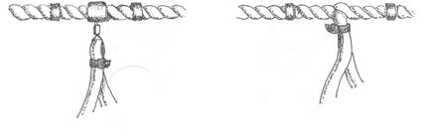

Fig 1a. Design of Approved Bird Scaring Lines

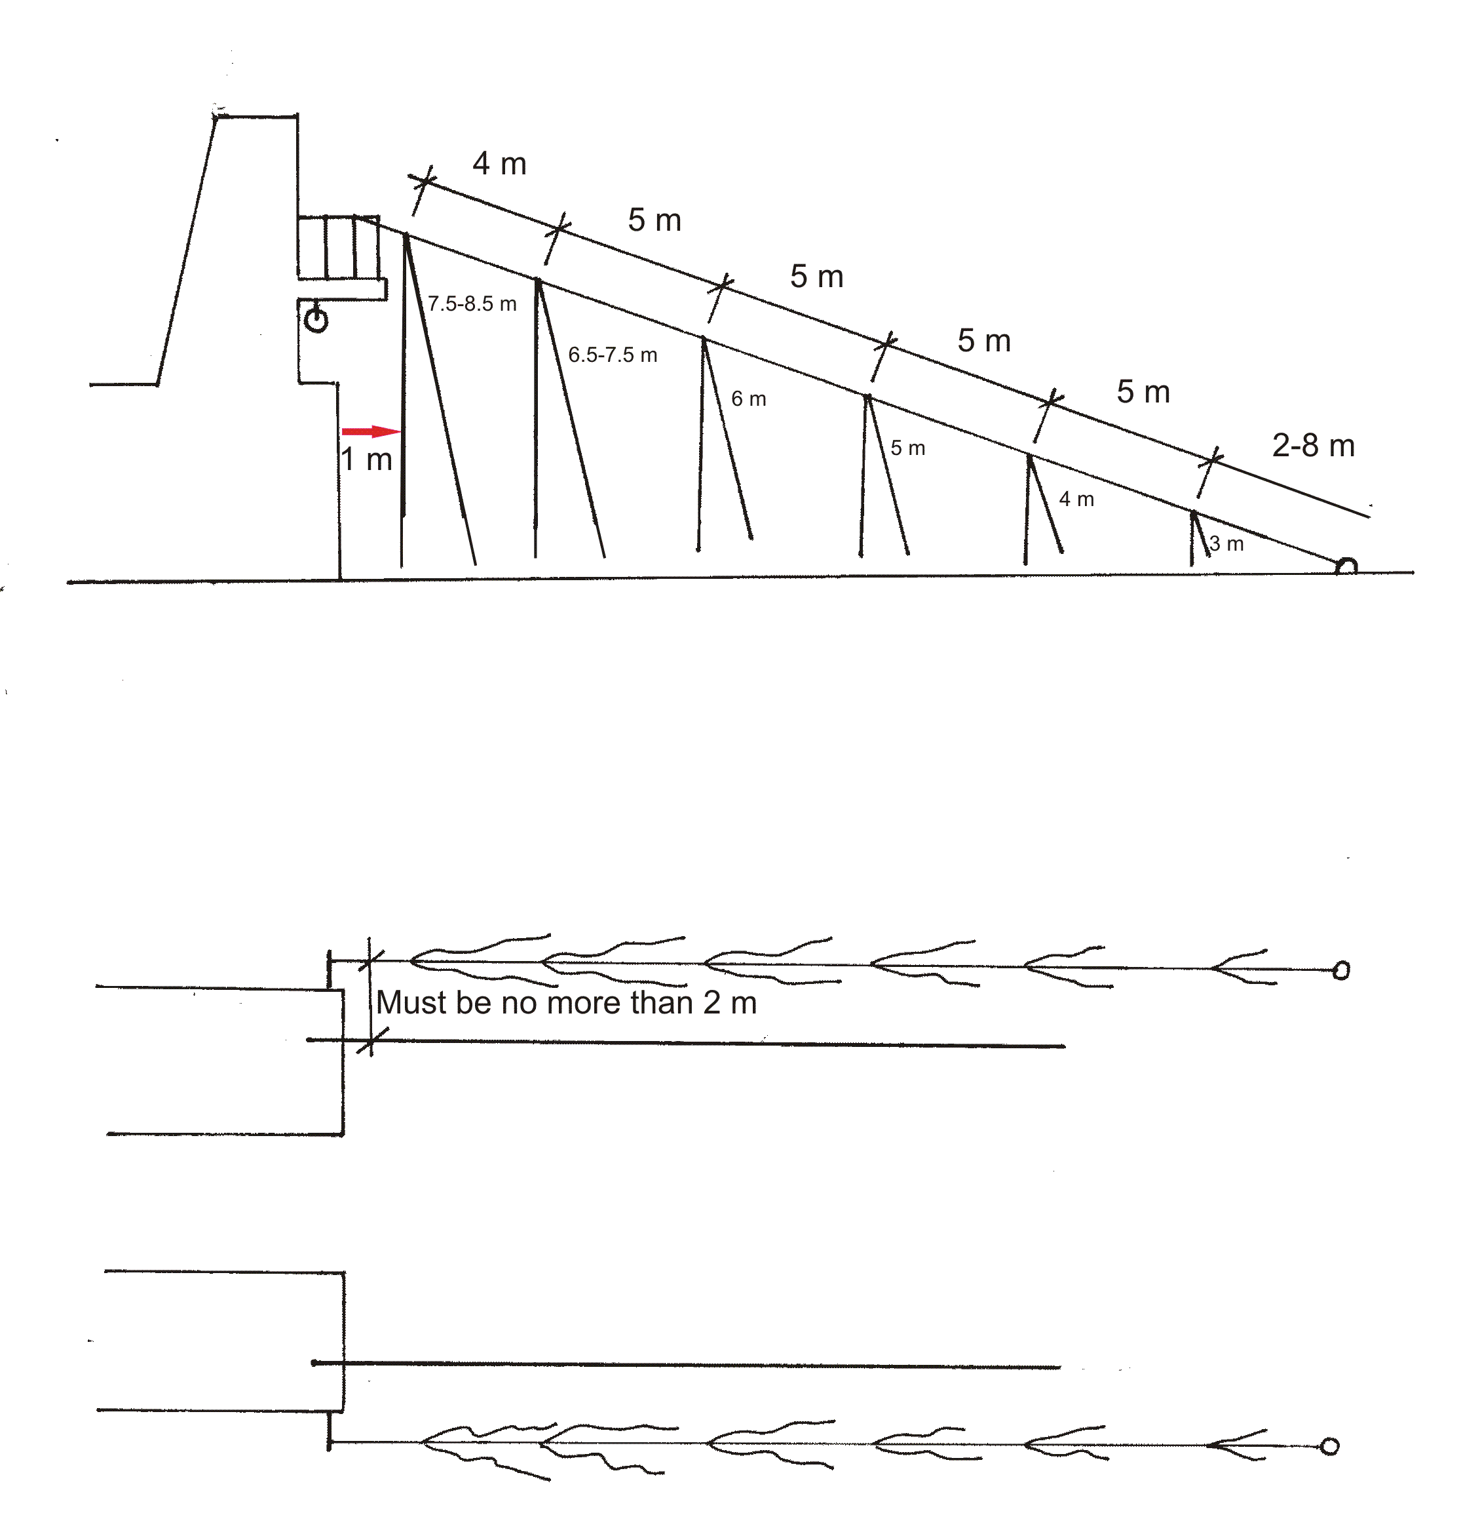

Fig 1b. Bird Scaring Line specifications

(i) The lines must be constructed from 8-10 millimetre coloured floating line (not black), either laid or pleated. The recommended total length of the line astern the vessel is 30 metres. Depending on the distance between the stern of the vessel and the warp/water interface, the total Bird Scaring Line length may vary between 27 metres and 33 metres. This variation in length can only be adjusted for between the last streamer and the buoy.

(ii) Six double streamers are to be attached at the intervals indicated in Fig 1. Attachment may be by light weight swivels (less than 50 grams) with stoppers or directly into the lay of the rope (Fig 1a). Streamer lengths range from 2 × 8 metre streamers closest to the stern to 2 × 3 metre streamers nearest the buoy. The length of the first set of streamers (2 x 8 metre and 2 x 7 metre) may be adjusted to optimise mobility and reduce drag (Fig 2). The length of these two sets may vary between 2 x 7.5 - 8.5 metres and 2 x 6.5 - 7.5 metres for the first and second respectively (Fig 1a).

(iii) It is mandatory that the streamers are made from semi-flexible red tubing. The recommended tubing is Red Mazzerpur 10 millimetre polyurethane tubing.

(iv) The drag buoy is a net covered 300 millimetre diameter HDP moulded fishing float attached by a swivel. Any other buoys are not permitted.

6.2 Fixed Aerial Array

- All trawlers using a Fixed Aerial Array must have two stern booms.

- Paired streamers attached to a line that is connected to the stern booms and lateral sides of the vessel to form a protective curtain around the warp cables (i.e. at least one lateral curtain at starboard and one at portside; at least one distal curtain from the tip of one boom to the other).

c) The streamer protective curtain needs to be such as to provide sufficient distal and lateral coverage to cables, including (and most importantly) at the warp-water interface.

- Double streamers should be sufficiently long just to maintain contact with the water surface in a swell and strong wind.

- In order to minimise warp entanglements, snapping, and keeping streamers free of warp grease, double streamers should not be excessive in length.

- Double streamers must be spaced apart equal to, or less than, 1.5 metres.

- It is required that the streamers be made from 8-10 mm semi-flexible red tubing. The recommended tubing is Red Mazzerpur 10 millimetre polyurethane tubing.

- To minimise streamer deflection in strong winds, weighted streamers and recommended.

- A pair of Tori Lines must be available for immediate deployment in the event of a malfunction with either of the two Fixed Aerial Array booms in use.

  - SEAL EXCLUSION DEVICES (SEDS)

Mitigation of Seal Mortalities

This section is to be applied by vessels fishing on any licence type, if instructed to do so by the Director of Natural Resources.

In order to minimise seal incidental mortality:

- An approved SED must be installed to allow the fur seals and sea lions to escape safely from the net.
- During the haul, the deck crew should make their best efforts to detect seals trapped in the net and facilitate their escape whilst the SED is still in the water, by working cables and bridles back and forth.
A) Three models of SED have been approved as depicted in the diagrams A, B, &C in section 15 below.
The standard components are:
- A rigid metal grid with vertical bars. The grid is likely to be most effective if it matches the shape of the net at the point of attachment
- The angle of the grid with respect to the bottom of the net must be 45°-70° to easily guide the seals to the escape hatch;
- The space between the vertical bars must be ≤ 15 cm;
- The shape of the top escape hatch should be either semi-circular or triangular with the base at the top of the grid, and it must keep its shape at all times. The distance from the base to the apex of a triangular design or zenith of a semi-circular design must be at least 100cm.
- The seal escape hatches (top and internal) must be at least 120 cm wide or 90% of the top bar of the grid, whichever is the greater.
- The dimensions of the internal seal escape hatch must be at least 100 cm above the bottom of the net, as indicated by the red vertical arrows in the diagrams below.
- All escape hatches must not be obstructed by any mesh or ropes.
- Several floats should be attached to both the upper side of the grid and the border of the escape hatch in order to allow proper SED flotation during shooting and hauling of the net.
- If an optional wing is installed at the base of the top escape hatch, its maximum width x₁ should be not more than a quarter of the SED’s escape hatch length x₂ as seen in the diagram below, and should have enough flotation to avoid covering any part of the top seal escape hatch, in order to maximise the opportunity for seals to escape.
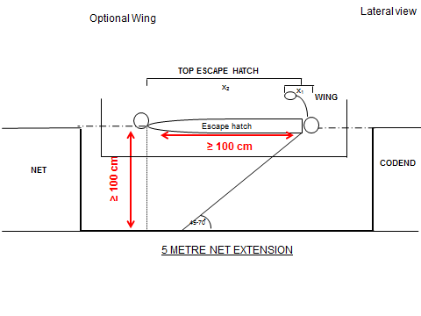
B) Approved net configurations with SED:
- SED – Model A: The SED is installed in a net extension piece [a net extension of c 5m has proved effective] in front of the codend to improve the water flow (Fig.1, 2).
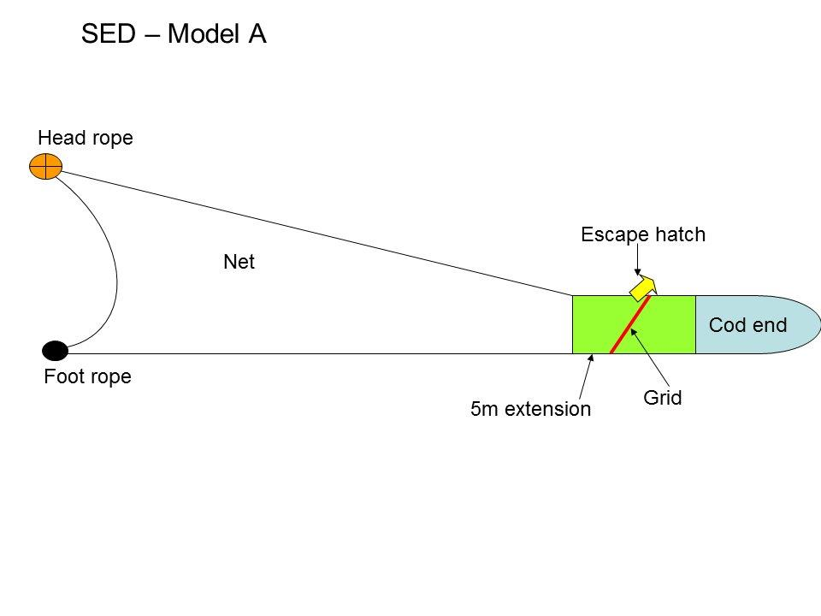
Fig.1. General diagram SED-A with 5 m net extension

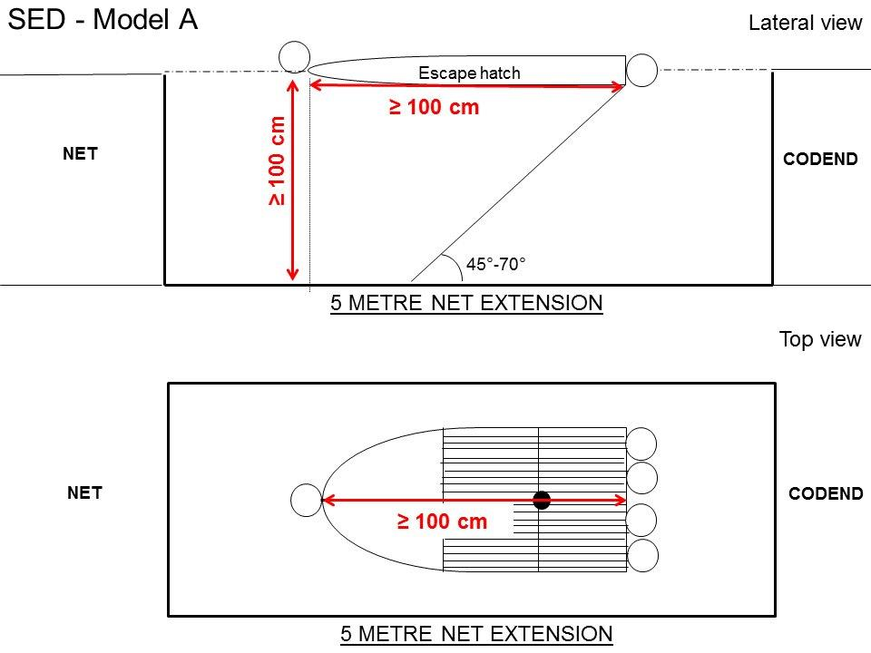
Fig.2. Lateral and top view of SED-A.
- SED - Model B: A small mesh panel is installed to direct the water flow to the lower part of the grid (Fig.3, 4).
- The escape hatch in the small mesh panel must have the same dimensions as the escape hatch at the top of the net;
- The base of the mesh panel must be attached only to the sides of the grid. Ropes attaching the mesh panel to the grid are not permitted.
- The point at which the small mesh panel connects or meets the grid must be at least 100cm above the bottom of the net when measured vertically.

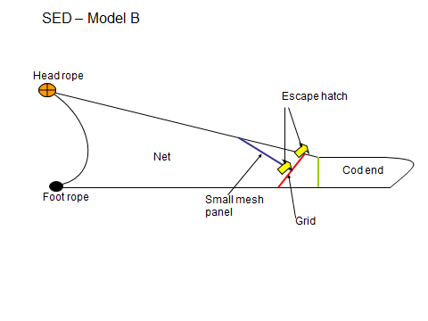
Fig.3. General diagram SED-B
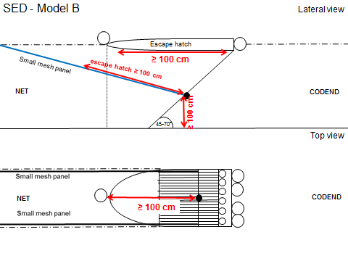
Fig.4. Lateral and top view of SED-B.

- SED - Model C: A small mesh funnel is installed to direct water flow towards the grid (Fig.5, 6).
- The width of the small mesh funnel must be at least as wide as the escape hatch at the top of the net;
- The small mesh funnel must be attached only to the sides of the net. Ropes attaching the funnel to the grid are not permitted.
- The horizontal distance from the mouth of the small mesh funnel to the bottom of the grid must be at least 100 cm.

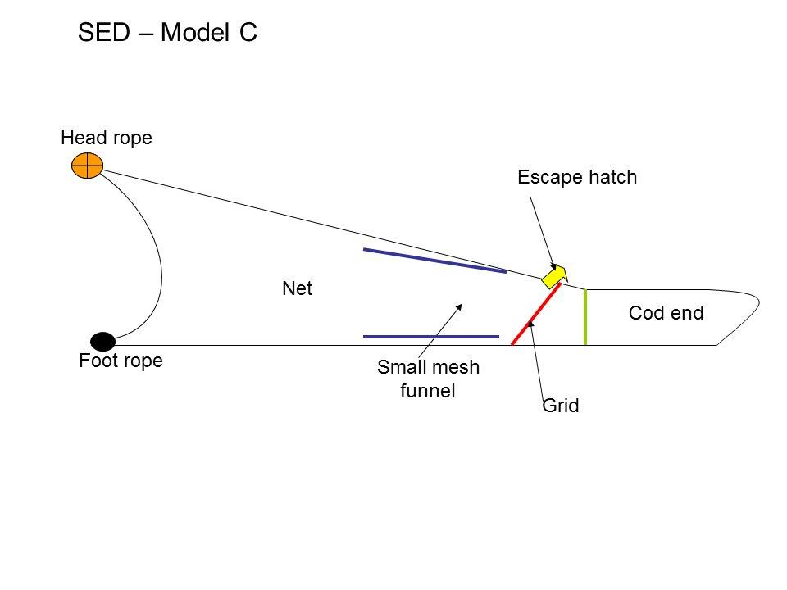
Fig.5. General diagram SED-C.
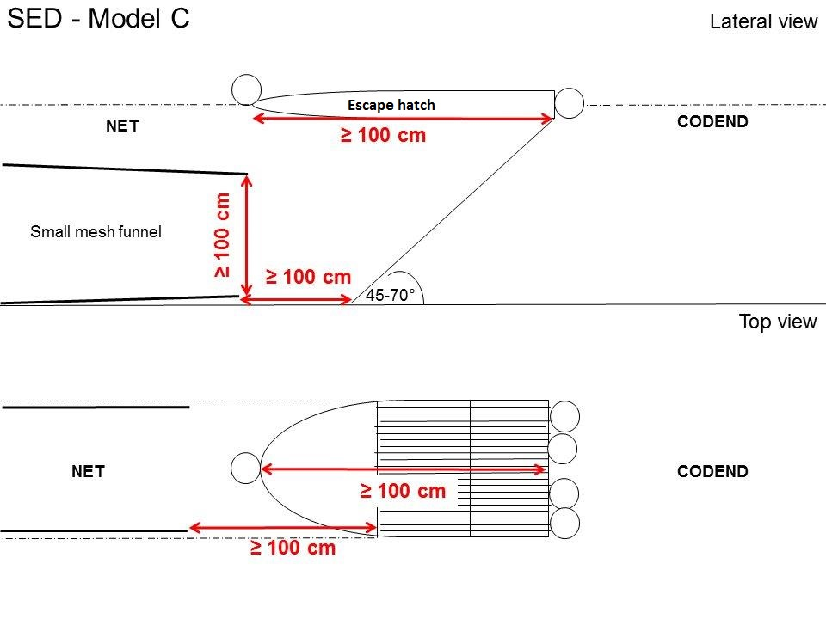
Fig.6. Lateral and top view of SED-C.
For attachment of either the small mesh panel (SED-B) or funnel (SED-C), a PVC tube with a rope inside is recommended, as it gives stability.

Fig.7. Compliant SED-B. The arrows indicate the attachment of the small mesh panel to the sides of the net. The internal escape hole is neither blocked by ropes nor mesh. Note the PVC tube in the border of the panel.

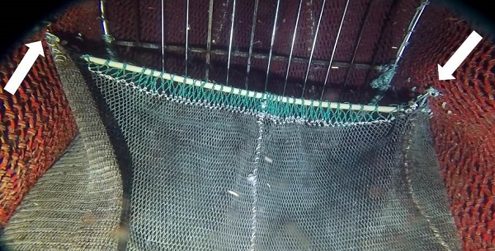

  - Guidance for masters to follow in the case of mortalities is set out below

In the situations where a MMO is either not on board or is unable to work the following guidance should be followed:

- Marine Mammal mortality - The catch report should include photographic evidence of the mortality: including one close-up photograph of the head of the animal, with clear and focused view of the eye and ear of the animal; one close-up photograph showing the mid-ventral portion of the body of the animal and tail; one photograph showing the full body. ALL photographs must be in colour, and at least 1200 pixels density, in focus and adequately lit. Photographs must be marked with callsign, date, trawl number, mortality. For example: if one mortality occurs in the second trawl of the day, the naming should be: ZDLN4_290721 _T2_mortality. If two mortalities occur, photographs of each individual are needed. For example: two mortalities in trawl 3, the naming should be: ZDLN4_290721 _T3_mortality.1; ZDLN4_290721 _T3_mortality.2.

- Seabird mortality – if seabird mortalities do occur the seabird carcass should be collected and then frozen inside a bag. The name of the vessel should be written on the bag. A label with callsign, date, trawl number and trawl coordinates should be included inside the bag.

All photographs should be sent to viriarte@naturalresources.gov.fk


FISHERIES DEPARTMENT
STANLEY FALKLAND ISLANDS
OBSERVER VESSEL SAFETY BRIEF

The following points are the minimum points we require you to cover each and every time an observer boards your vessel.
Points to cover | Covered
Location of muster points
Location of life vests
Location of survival suit
Location of lift raft
Meaning of vessel alarms
Escape route from factory deck

Any other vessel specific points covered:

As per your licence conditions a safety briefing must be provided to the Fisheries Observer as soon as they arrive on board, so that they are aware of safety procedures in the event of an emergency.
Please sign below stating that you have received a safety brief.
Observer:

Print name:_____________________________ Sign:________________________________

Please sign below stating that you have given a safety brief.

Crew member designation ______________________________________________________

Print name:_____________________________ Sign:________________________________

