Permit Process for employers – September 2021

The below is comprehensive but not exhaustive guide to familiarize employers with the new Immigration permit application forms. If you have any questions that are not covered in this document, email us on permits@customs.gov.fk

More information and contents can be obtained from our website https://www.fig.gov.fk/customs and from the FIG Legislation portal https://www.legislation.gov.fk

- Work Permits

- Permission to Employ

- Medical Requirements

- Advertising

- Vetting Certificates

Glossary:

C&I – Customs & Immigration Service

WP – Work Permit
ADP – Accompanying Dependent Permit
DP – Dependent Permit
RP – Residence Permit

ER – Employer
EE – Employee

WSL – Workforce Shortage List

RES – Registered Employer Scheme

MPC – Mount Pleasant Complex

WORK PERMITS
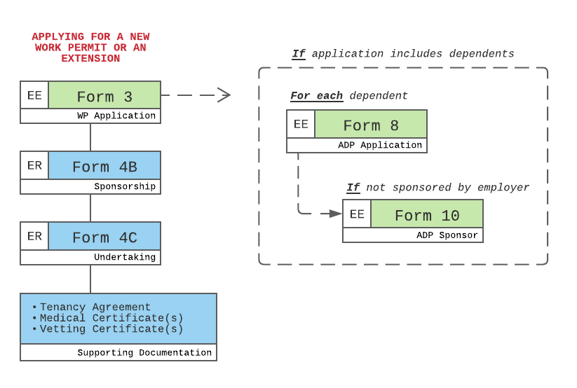
The above chart displays the most common combination of forms used for applying for a Work Permit, this is for new applications and extensions.

Form 3 is for the applicant, and Form 4B (Sponsorship) and Form 4C (Undertaking) are for the employer.

ACCOMPANYING DEPENDENT PERMIT

If the application includes dependents of the Work Permit applicant, each dependent will need to complete a Form 8 – an application for an Accompanying Dependent Permit (ADP).

If the dependent is not being sponsored by the employer, then the Work Permit applicant will need to complete an additional Form 10 – confirming that they will sponsor the ADP(s).

SUPPORTING DOCUMENTATION

Supporting documentation applied to the Work Permit applicant and Accompanying Dependent Permit applicant(s).

Up to date medical forms can be downloaded from the Customs & Immigration website.

Vetting certificates or Criminal Record Checks need to be produced for the main applicant and for any potential accompanying dependents aged 16 or over, for every country the individuals have lived for at least 12 months within the last 5 years and one for the country of origin, unless the individual left the country before the age of 16.

SCHOOL ASSESSMENTS

If any Accompanying Dependent Permit applicants are of school age, school assessments are to be completed and submitted to the relevant school (either IJS or FICS).

A Work Permit application and Accompanying Dependent Permit application is not complete and will not be processed unless all the correct forms and supporting documentation are submitted.

PERMISSION TO EMPLOY
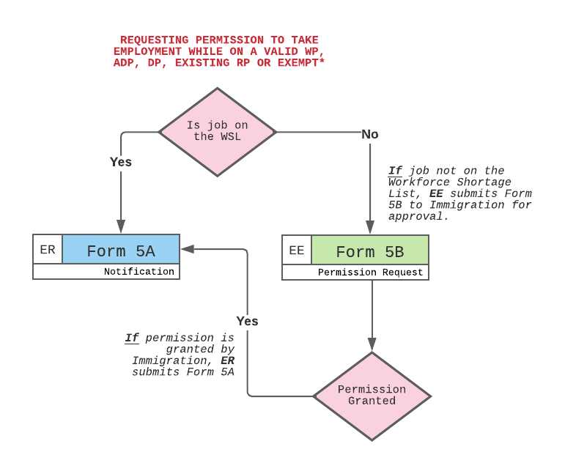
Employers who are part of the Registered Employer Scheme (RES) can opt to offer employment to individuals who are on:

- Work Permits (WP)
- Accompanying Dependent Permits (ADP)
- Dependent Permits (DP)
- existing (legacy) Residence Permits (RP)
- or are exempt (SGSSI, MoD Dependent)

The requirement for the employer to advertise the role remains in all cases.

The RES forms:

To be completed by the employer –

Form 4A – Employer registration
used to register initially on the RES

Form 4B – Work Permit sponsorship
for those employees being sponsored by the employer

Form 4C – Employer’s undertaking
used in conjunction with Form 4B

Form 5A – Employer’s notification
used to notify C&I when taking on an individual included on the above bullet-pointed list

To be completed by the employee –

Form 5B – Employment permission
used by the prospective employee when seeking permission to undertake employment not included on the WSL, or in any instance if a holder of a RP or if an exempt individual

The process:

If the role is on the current Workforce Shortage List (WSL), the employer can simply complete a Form 5A notifying the Customs & Immigration Service of their intention to offer employment to a permit holder. The Customs & Immigration Service will then conduct the relevant checks and return a notification with an authorisation.

If the role being recruited is not on the WSL then the prospective employee will need to complete a Form 5B and send it to the Customs & Immigration Service to request permission to take the employment. If permission is granted confirmation of this will be sent to the employee and this can then be presented to the employer who will then need to submit Form 5A for notification.

Those holders of Dependent Permits (DP) will not need to complete a Form 5B requesting permission to take up a role not on the WSL.

For those individuals holding (legacy) Residence Permits (RP) and those exempt individuals (SGSSI and MoD dependents) they will need to complete a Form 5B and send it to the Customs & Immigration Service - regardless of whether the role is included on the WSL or not.

In all cases the employer must notify C&I by submitting a Form 5A. This form must be submitted within 5 days of the employer taking the individual on.

Any changes to the employment of the individual should be communicated to C&I as soon as practical. The exact requirements of the Immigration Regulations 2021 in relation to the RES and employers duties can be found by following the below website link -

The latest Workforce Shortage List can be found on:
https://fig.gov.fk/customs/for-employers

MEDICAL REQUIREMENTS

To be completed by the applicant / employee -
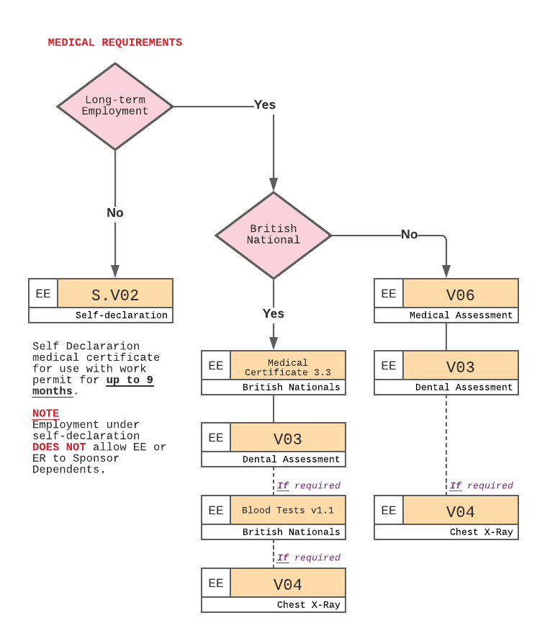
SHORT-TERM SELF-DECLARATION

Short-term employment for up to 9 months can be obtained with a valid Medical Self-Declaration.

Self-declared employees need to be covered with an Insurance Policy, details on the type and coverage expected can be found on page 1 of the Medical Self-Declaration Form (S.V02).

LONG-TERM MEDICAL ASSESSMENT

A full medical assessment can be signed for up to 5 years.

In contrast with the Medical Self-Declaration, a Dental assessment is also necessary.

A chest x-day may be required by the hospital. Details on this requirement can be found on form V04 (Chest X-Ray Certificate).

LONG-TERM MEDICAL ASSESSMENT (BRITISH NATIONALS)

British nationals can access a different set of forms that might exclude parts of the Long-term Medical Assessment to expedite the obtaining of a signed-off assessment

This medical is also issued for up to 5 years.

As well as with the Long-term Medical assessment, a Dental assessment is necessary.

Blood test and chest X-rays might be necessary, these forms will be sent out with the suite of forms and should be completed if necessary – the guidance included in and with the forms will inform this, applicants should read this carefully.

Completed medical paperwork SHOULD NOT be sent to the Customs & Immigration Service, all medical paperwork should be forwarded to medicals@kemh.gov.fk, if employment is based in Stanley or Camp, or to the MPC MedCentre if based in MPC.

ADVERTISING

Employer responsibility /duty -
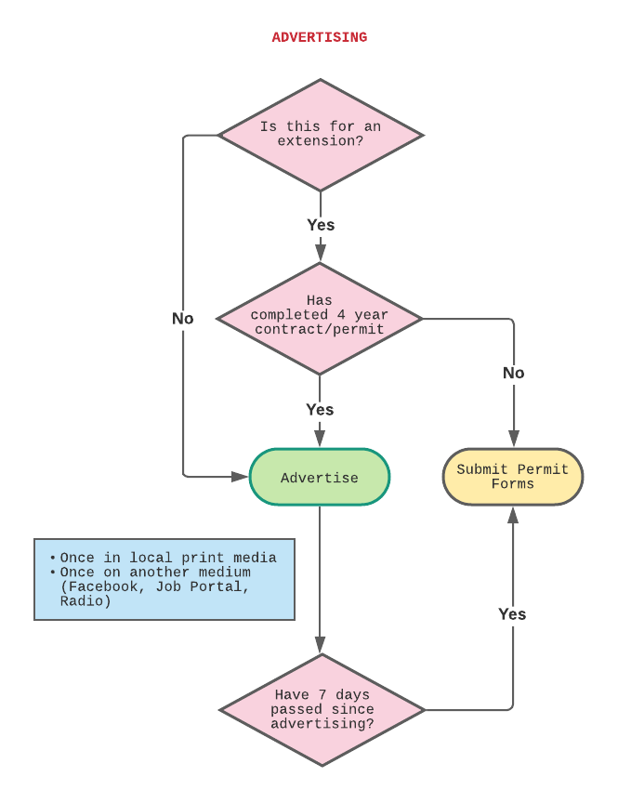

Advertising of employment vacancies continues to be a requirement.

The C&I advertising policy now states that the employer must advertise at least once in the local print media (Penguin News) and another form of advertising such as radio (FI Radio, BFBS FI), employer’s website, social media, job portal or alternative format.

The details of the advertising must be included in Form 4B (WP sponsorship) or Form 5A (Employer’s notification) depending on how the recruitment has taken place.

Form 4B (Work Permit sponsorship) or a Form 5A (Employer’s notification) cannot be submitted before 7 days since first advertising in the local print media.

Change to advertising requirements:

Advertising for a Work Permit extension is no longer a requirement if with the extension the permit’s validity is no longer than 4 years in duration. A permit cannot be extended past 4 years – a new permit will be required at this point – with the required advertising. New ADP(s) will also be required – if there are any ADP(s) connected to the Work Permit.

In all instances a substantive change in a job role or a promotion will require the job to be advertised, and a new Work Permit to be applied for by the employee (with new ADP(s) if applicable).

If the employee is a holder of an ADP, DP, RP, or is exempt, and there is a substantive change or a promotion then the job must also be advertised, they will however not need to apply for a new permit.

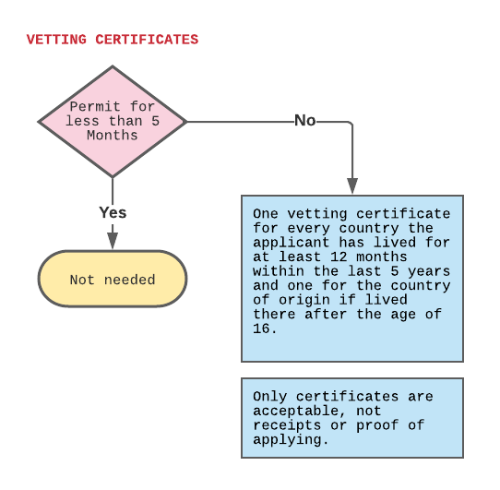
VETTING CERTIFICATES

Vetting Certificates are not necessary for employment under 5 months.

For long-term employment the permit applicant will need to submit one Vetting Certificate for every country they have lived in for at least 12 months within the last 5 years, and one for their country of origin if lived there since the age of 16.

Accompanying Dependent Permit applicants aged 16 and older must also include vetting certificates meeting the same requirements.

Vetting certificates cannot be older than 90 days of the date of the application.

Only national police checks are accepted (ACRO [UK], SAPS [ZA], NBI [PH], SRCI [CL], etc)

NOTES

Up to date forms and information can be found on our website: https://www.fig.gov.fk/customs

If possible avoid printing off paper copies completing by hand and submitting, or scanning hand-completed copies, instead complete the forms electronically in their Word format and email to permits@customs.gov.fk

